Mine Fleet Sensor Data API Design Description
By: Sama Al Kamachy
Date: 06 February 2026

- Background:
A temperature sensor installed on mining equipment periodically sends temperature readings to the Mine Fleet Sensor Data API (MFSD). The MFSD processes incoming sensor data, validates it, persists it, and triggers an alert to the operator if the temperature exceeds a defined threshold.
This design is test-driven: all features are developed with unit tests and system tests to ensure correctness, validation, and consistent API responses.
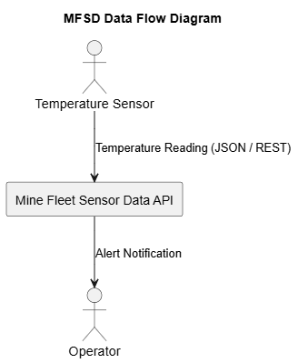
Figure 1: MFSD Data Flow UML Diagram

- Tools:
Table 1: MFSD tool set table
Name | Version | Description
Git | Latest | SCM
Github | Latest | Remote repository hosting
Visual studio code | Latest | IDE
Java | 17.0 | Coding language
Spring boot | Latest | Java REST framework
Maven | Latest | Build tool
Junit | Latest | Java unit testing framework
PlantUML | Latest | UML tool
- Test-Driven Development (TDD)
Development will start with the creation of the following unit tests, detailed in table 2, which are written to conform to the system tests. Automated tests are run via Maven (mvn test) to ensure all functionality is working.
Table 2: MFSD system and unit test matrix
System Test ID | Unit Test ID | Purpose
ST-01 | UT-01 | POST /sensors accepts valid sensor data
ST-02 | UT-02 | POST /sensors rejects missing/invalid fields
ST-03 | UT-03 | Repository stores multiple sensor readings in-memory
ST-04 | UT-04 | GET /sensors/{id}/latest returns latest reading
ST-05 | UT-05 | GET /sensors/{id}/latest returns 404 if not found
ST-06 | UT-06 | Validate all JSON responses follow the consistent schema.

- Non-Functional Requirements
Performance: In-memory storage ensures low-latency responses
Maintainability: Layered architecture, modular design
Usability / Developer-Friendly: Clear JSON responses, error handling and Java best practices
Testability: Unit tests and system tests defined; automated via Maven
Traceability: Requirements are traceable to system tests and unit tests. All code and documentation are version-controlled in GitHub.
- API Endpoints
Table 3: MFSD API Endpoints
Endpoint | Method | Description
/sensors | POST | Submit new sensor reading
/sensors/{id}/latest | GET | Retrieve latest reading

- Architecture
The Mine Fleet Sensor Data API uses Layered Architecture (Controller → Service → Repository → Model), designed to satisfy all functional and non-functional requirements.
Components and Responsibilities
Table 4: MFSD Components and responsibilities table
Component | Responsibility
TemperatureController | - Receives sensor data via REST endpoints.  - Maps JSON → model, calls service.  - Returns JSON responses.
TemperatureService | Contains all business logic:  - Validates sensor data,  - Checks thresholds (e.g., temperature > 100),  - Triggers alert if necessary,  - Calls repository to persist data
TemperatureRepository | Persists sensor data, retrieves historical data or latest readings
TemperatureReading | Represents the domain data:  Sensor ID, timestamp, temperature

- Sensor submits data to the REST endpoint.
- Controller maps request JSON → TemperatureReading model and calls Service.
- Service validates required fields, applies business rules (threshold checks), calls Repository to persist the reading.
- Service triggers alert logic if thresholds are exceeded.
- Controller returns success/error JSON to sensor/operator.
- Operator receives alert notifications (if applicable).
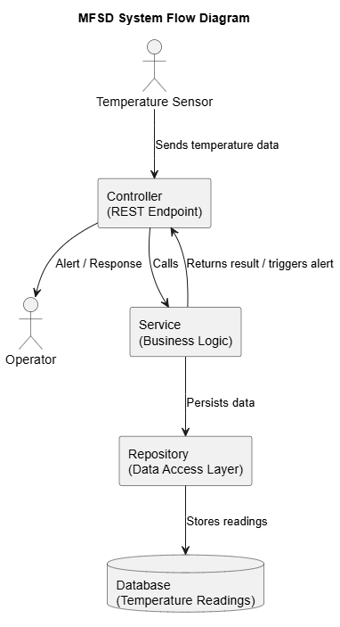
Figure 2: MFSD System Flow Diagram

